PERIODIC TEST-I
MARKS OBTAINED

TOTAL 20
NAME: ____________________
SUBJECT: English
GRADE: 3 ____
DATE: 11. 7. 22
TIME : 1 Hr

I. Choose the correct answer. (4×1=4)

1. Some nouns help us describe groups of animals,people or objects of the same kind. They are called __________.

- Collective noun C. Proper noun
- Abstract noun D. Common noun

2. A ___________ of bees is flying.

- Herd C. Bunch
- Swarm D. Pack

3. A ___________ sentence indicates that something is false or not true.

- Positive C. Negative
- Affirmative D. None of the above

4. Every poem is divided into ___________.
- Stanza C. Rhyme
- Paragraph D. Sentence

II. Match the following action with its meaning. (4×1/2=2)

5. Lick - Communicate
6. Hiss - Happy
7. Purr - Unhappy
8. Meow - Affection

III. Answer the following. (3×2=6)

9. How did Harry treat his pet cat.?
____________________________________________________________
____________________________________________________________
____________________________________________________________
____________________________________________________________

10. How would you feel if someone treated you the way Harry treats his cat?
____________________________________________________________
____________________________________________________________
____________________________________________________________
____________________________________________________________

11. Write 3 collective nouns with sentences
____________________________________________________________
____________________________________________________________
____________________________________________________________
____________________________________________________________

IV. Write a sentence using collective nouns to each of the following pictures. (3×1=3)

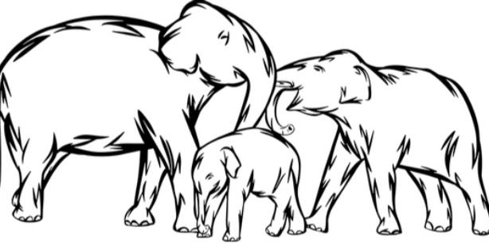 12. _____________________

13. ______________________

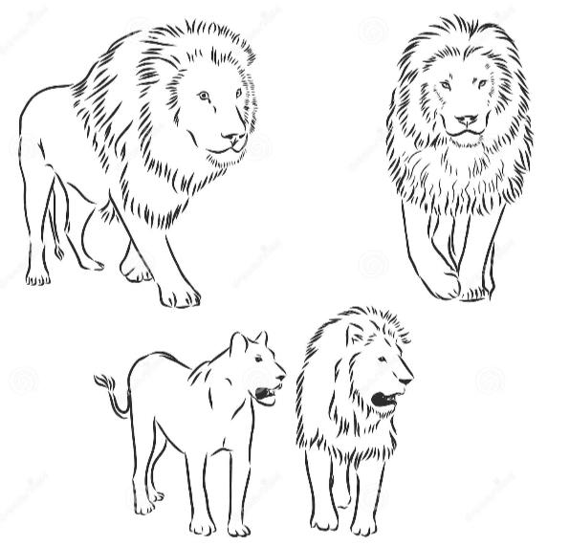 14. _____________________

V. Underline the rhyming words in the following poetic lines. (1×2=2)

I had a cat
Who was so fat
He could not even
Sit on his mat
He had a hat
That did not fit
He put it on
And then it split.

VI. Convert the following positive sentences into negative sentences.
(3×1=3)

Positive | Negative
I like fruits.
She feels good
I play chess

.

